Hatch End
Riverside Park Newsletter 6

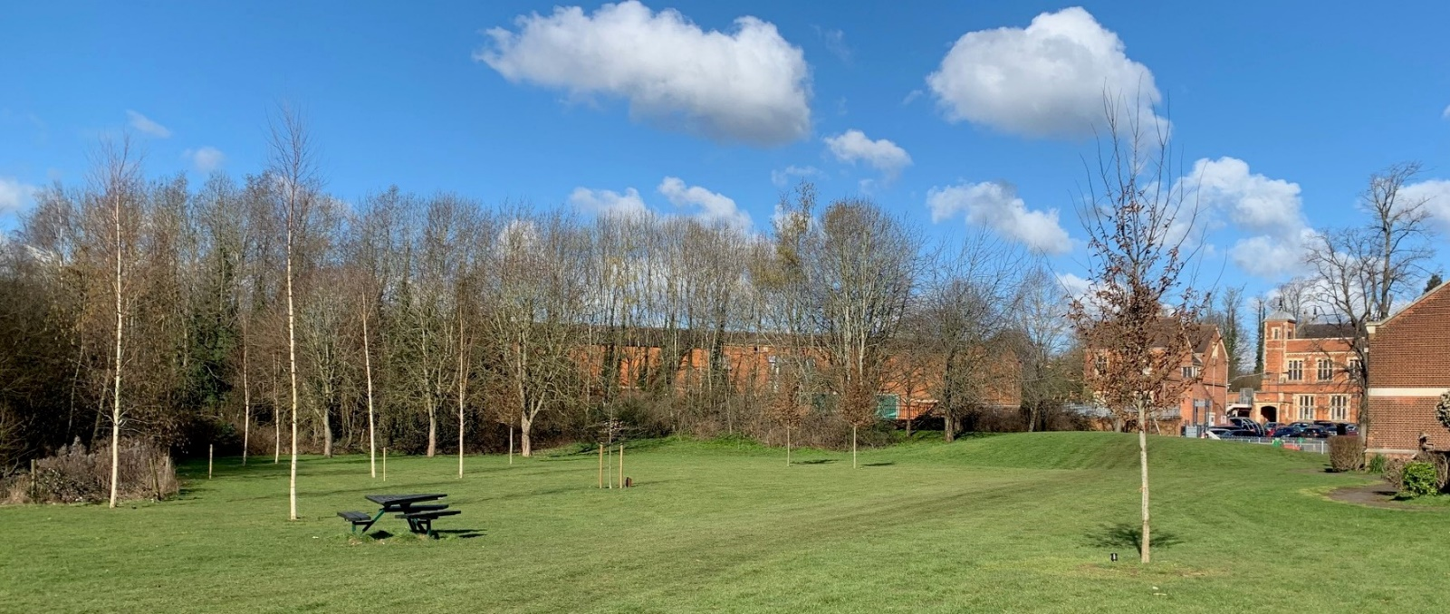
Where is it? | Behind Morrisons.
What is it? | It is a new Hatch End park, encircled by the River Pinn.
What’s the latest: | Works starts 23 October.

The Hatch End Association in conjunction with Harrow Council and the Harrow Arts Centre are in the process of creating the new Riverside Park
The first meeting of ‘The Friends of the Riverside Park’ will be announced shortly for those who would like to support the running and development of the Park. If you wish to participate please contact Graham Buckland, the Chairman designate on grahambuckland1@aol.com or visit the HEA website www.hatchend.org

Hatch End
Riverside Park Newsletter 6
Contract Progress
We are delighted to announce that the Harrow Council has now placed contracts for the sinuous path around the Park, the raised stage outside the Dance Studio and Swimming Pool, the Park furniture and the seeding of the wildflower meadow. This has been a difficult process with high inflation within the contracting industry, and we thank the Council project team and our Councillor Matthew Goodwin-Freeman for their perseverance to make this happen. Works will start on 23 October.
- Gravel path and 36m² Stage – scheduled for completion in November 2023.
- Wildflower meadow – scheduled for sowing this month.
- Benches – contractors will return to site and install in January 2024.
During construction the park will be closed for the duration of the works and the playground closed from 30 October (but it will remain open on weekends).
Summer working parties
During the summer there have been three informal working parties on the site. The first was to remove the Giant Hogweed growing on the site which was done in conjunction with Steve Whitbread the Harrow Biodiversity officer. This made the site safe for future working groups.
Steve then funded two working days supported by the TCV (The Conservation Volunteers) in August and September. The first working day cleared about 40m of the River Pinn banks from brambles and saplings; the second thinned out the woods between the River Pinn and the railway line to bring light and new growth in the area preserved for wildlife (and which is the primary flood zone). A third working party is being scheduled for November and a date will be announced soon. At each working party we had a team of 7 or 8 people who turned up to help; tools, protective wear and safety equipment were provided by TCV.
The “Friends” of the Park
Once the Park works are completed, we will form a “Friends” group to help maintain and develop the Park further. There are already a number of volunteers. In the Autumn we plan to call an initial meeting of those interested and at the following meeting a month later to elect the first Committee. Please let Graham Buckland know if you would like to participate. The “Friends” group will be affiliated to the Harrow Parks Forum which is the independent body looking after over 200 green spaces in Harrow.

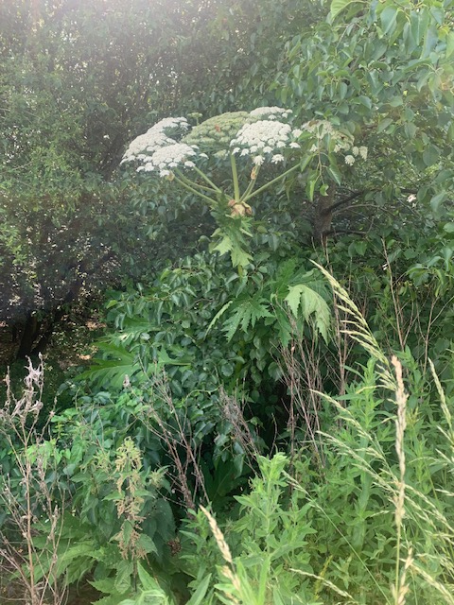
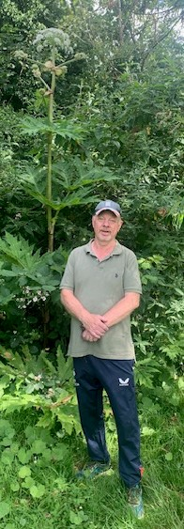
Giant Hogweed flowers and seed heads in May
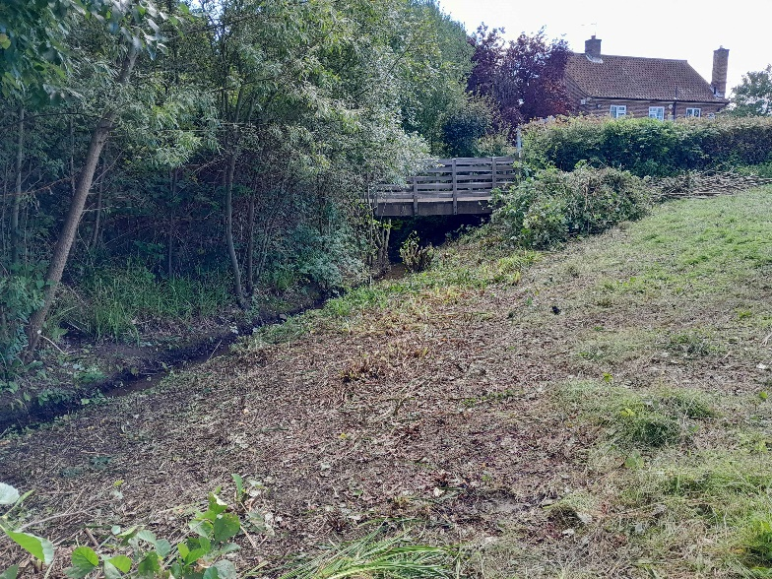
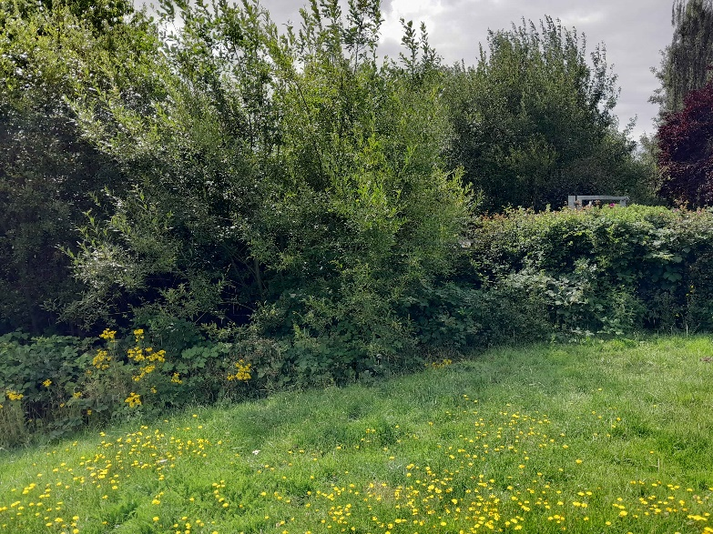
Working Party - Clearing the River Pinn banks in August (before and afterwards)
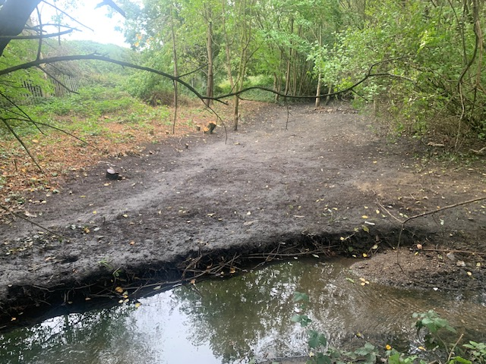
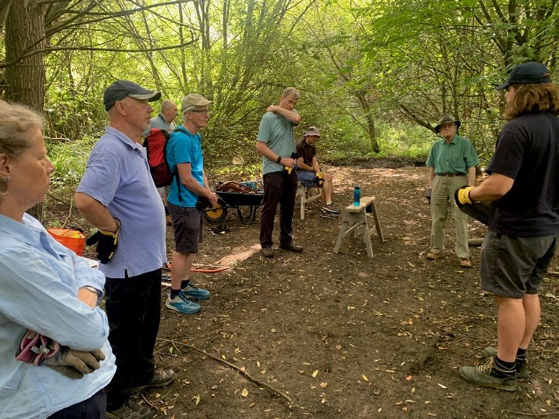
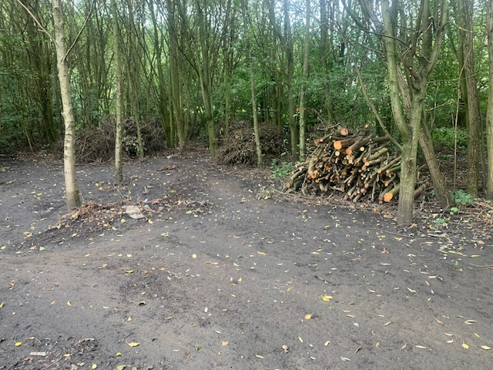
Working Party coppicing the woods behind the river in September

Current layout and tree locations for the Park
